Screenshots Record Conversions - DS3 Actions

Thursday, October 15, 2015

9:42 AM

\*\*Converting a record

* + A new care coordinator who is already a contact in DS3 can be converted from Contact to Provider easily.
  + Most if not all Assisted Living Homes (most common) that are contacts and are applying to be Medicaid Certified can be converted from contact to provider
  + Foster Parents who are becoming a Child Family Hab contractor entity can NOT be converted. (Limitation of the system for connecting the Habilitation contracted homes to an agency) Foster Parents or OCS based homes are special cases and must be entered as a NEW Provider entity.
  + If the home is “Suzy Smith and John Hotep” listed on the license then that is what the name of the Organization entity needs to be. These are also setup as ALH homes as further described later on.

Not written SharePoint Entries - Archives

Thursday, October 15, 2015

12:11 PM

<https://go.dhss.ak.local/dsds/archive/SitePages/Home.aspx>

Provider Certification Previous Volumes – Currently Certified ARCHIVE Data Entry Process

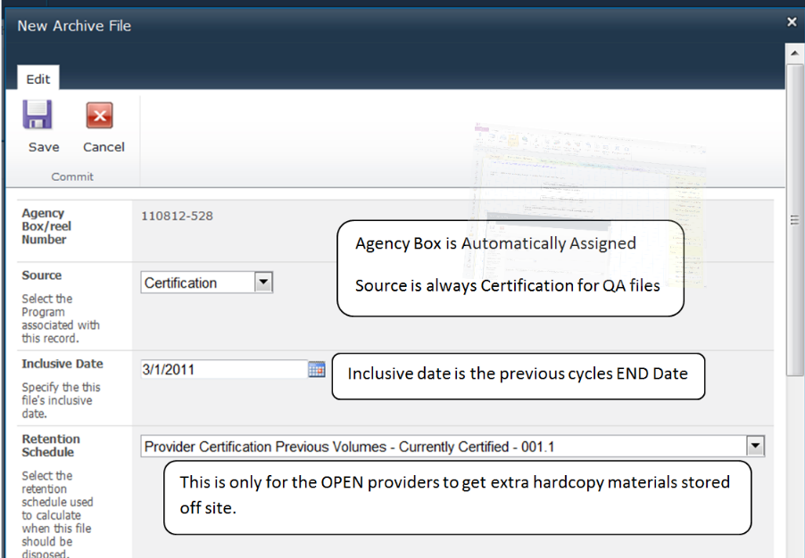

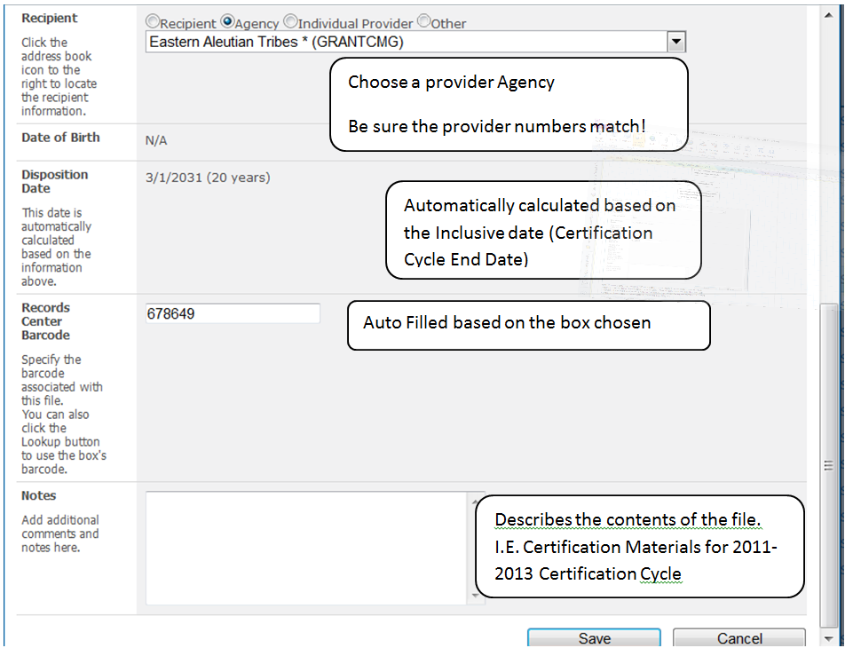

Hint: To make entering notes in DS3 more efficient for multiple entries per provider finish entering the box then download a report to Excel, filter to only show the box that was just finished, alphabetize and enter 1 note in DS3 for each provider noting the number of folders contained in the box and the contents from the Excel Report.

Screen clipping taken: 3/9/2016 8:19 AM

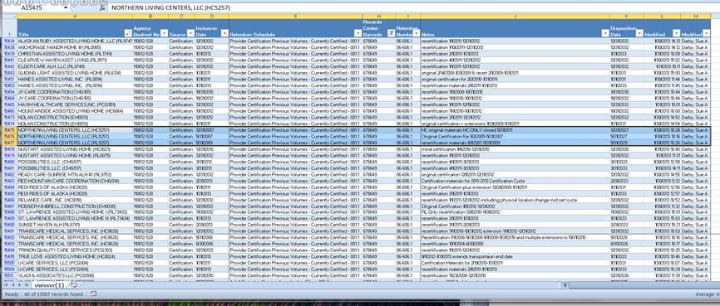

DS3 NOTES

Provider Record Location Note should have:

Agency Name:

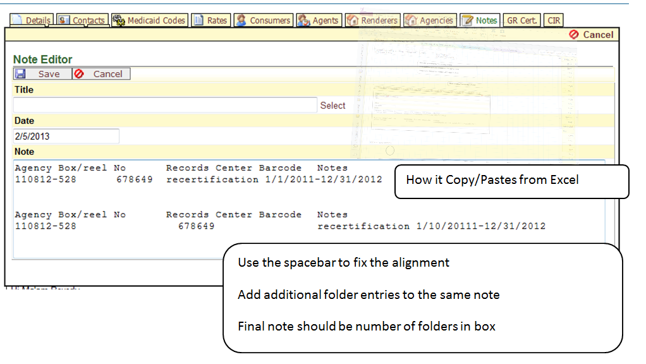

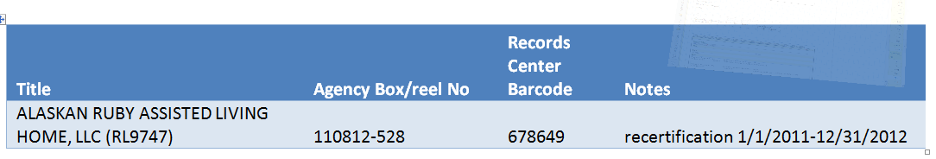

Agency Box No:

Records Center Barcode:

Notes:

Transferring to Archive

Machine generated alternative text: Favorites c4 j Date_ Q Quai... -$ Logi... fØ Stat. fØj Cnt.  Fix Ø http... fl Prit... ØJ Prin.. Ø Prin.. Ø Prog... ri Prov... Ø Prc jfr (ô D53 (ô Mcdi... 4$ provi.. 4$ Provi... j & X 4) State.-  $ iogi... fl Goo. . ÇJIÌ Page SiteActons— a —- ‘%Vsnion History J = Item Permissions Ness New New V Edit Attach Alert kern • Folder File k kern Delete kern File Me. New M se Actons S*iaee&Track Worldlows ApproveiReject I Like 109$ & k Notes Woetllows Taos and Notes Libraries w • Agency Box/reel No Box Status Disposition Dato Records Center Barcode Created Created By’? - Assigned To Shared Documents Transfer Documents d Box Status: In Progress (17) Lists Calendar Archived Boxes Archived Files 110812-539 110812-538 110812-537 110812-536 In Progress inProgress InProgress In Progress 11124/2011 678650 678659 678658 678657 11/8/20122:43 PM 11/8/20122:43PM 11/8/20122:43PM 11/8/2012 2:42 PM Darby, Sue A Daety,SueA Daoby,SueA Derby, Sue A Dad», Sue A Darby,SueA Darby,SueA Darby. Sue A r — I 110812-535 InProgress 678656 11/8/20122:42PM Darby,SueA Darby,SueA DiscussIons 110812-534 InProgress 678655 11/8/20122:42PM Darby,SueA Darby,SueA Team Discussion 110812-533 In Progress 678554 11/8/2012 2:41 PM Darby, Sue A Darby. Sue A 110812-532 In Progress 678653 11/8/20 12 2:41 PM Darby, Sue A Darby, Sue A Recyde Bes 110812-531 In Progress 678652 11/8/2012 2:41 PM Darby, Sue A Dad». Sue A -S All Site Content 110812-530 In Progress 678651 11/8/2012 2:41 PM Derby, Sue A Darby. Sue A ..-rv InProgress 678650 11/8/2o122:4OPM Darby,SueA Li.ru,, W 110812-528 Cerbfkation DO NOT ARCHIVE Box 1-176 In Progress !r’ Progress 3/31/2033 9/30/2010 678649 11/8/2012 2:40 PM 12/5/2011 11:35AM Darby, Sue A Darby, Sue A Derby, Sue A r, QA Provider Files 2002-2006-175 In Progress 4(30/2012 12/5/2011 10:29 AM Darty, Sue A Darby, Sue A QA Test Box-174 In Progress 11/30/201111:37 AM Darby. Sue A Darby, Sue A Closed Providers- 11 In Progress 2/5/2011 5/13/2010 2:09 PM Derby, Sue A 033010-9 QA Closed Complaints - Provider In Progress 3/30/2010 3:22 PM Darby, Sue A .‘ Trusted sites I Protected Mode: Off . k 115%

Choose a box to transfer

Go to Edit Item

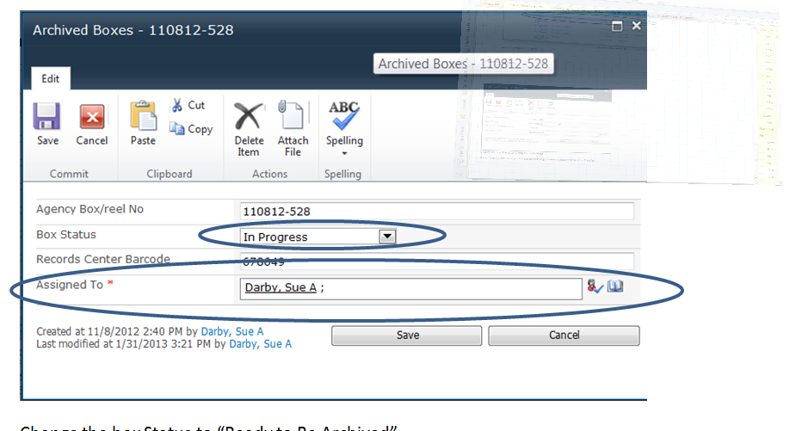

Change the box Status to “Ready to Be Archived”

Assign it to YOURSELF or you will not be able to generate the Report needed for Transfer!